**Storage Gateway**

Storage Gateway is a service in AWS that connects an on-premises software appliance with the cloud-based storage to provide secure integration between an organization's on-premises IT environment and AWS storage infrastructure.

Storage Gateway service allows you to securely store the data in AWS cloud for the scalable and cost-effective storage.

**LAB:**

Go to the Storage Gateway Service and Create a Gateway

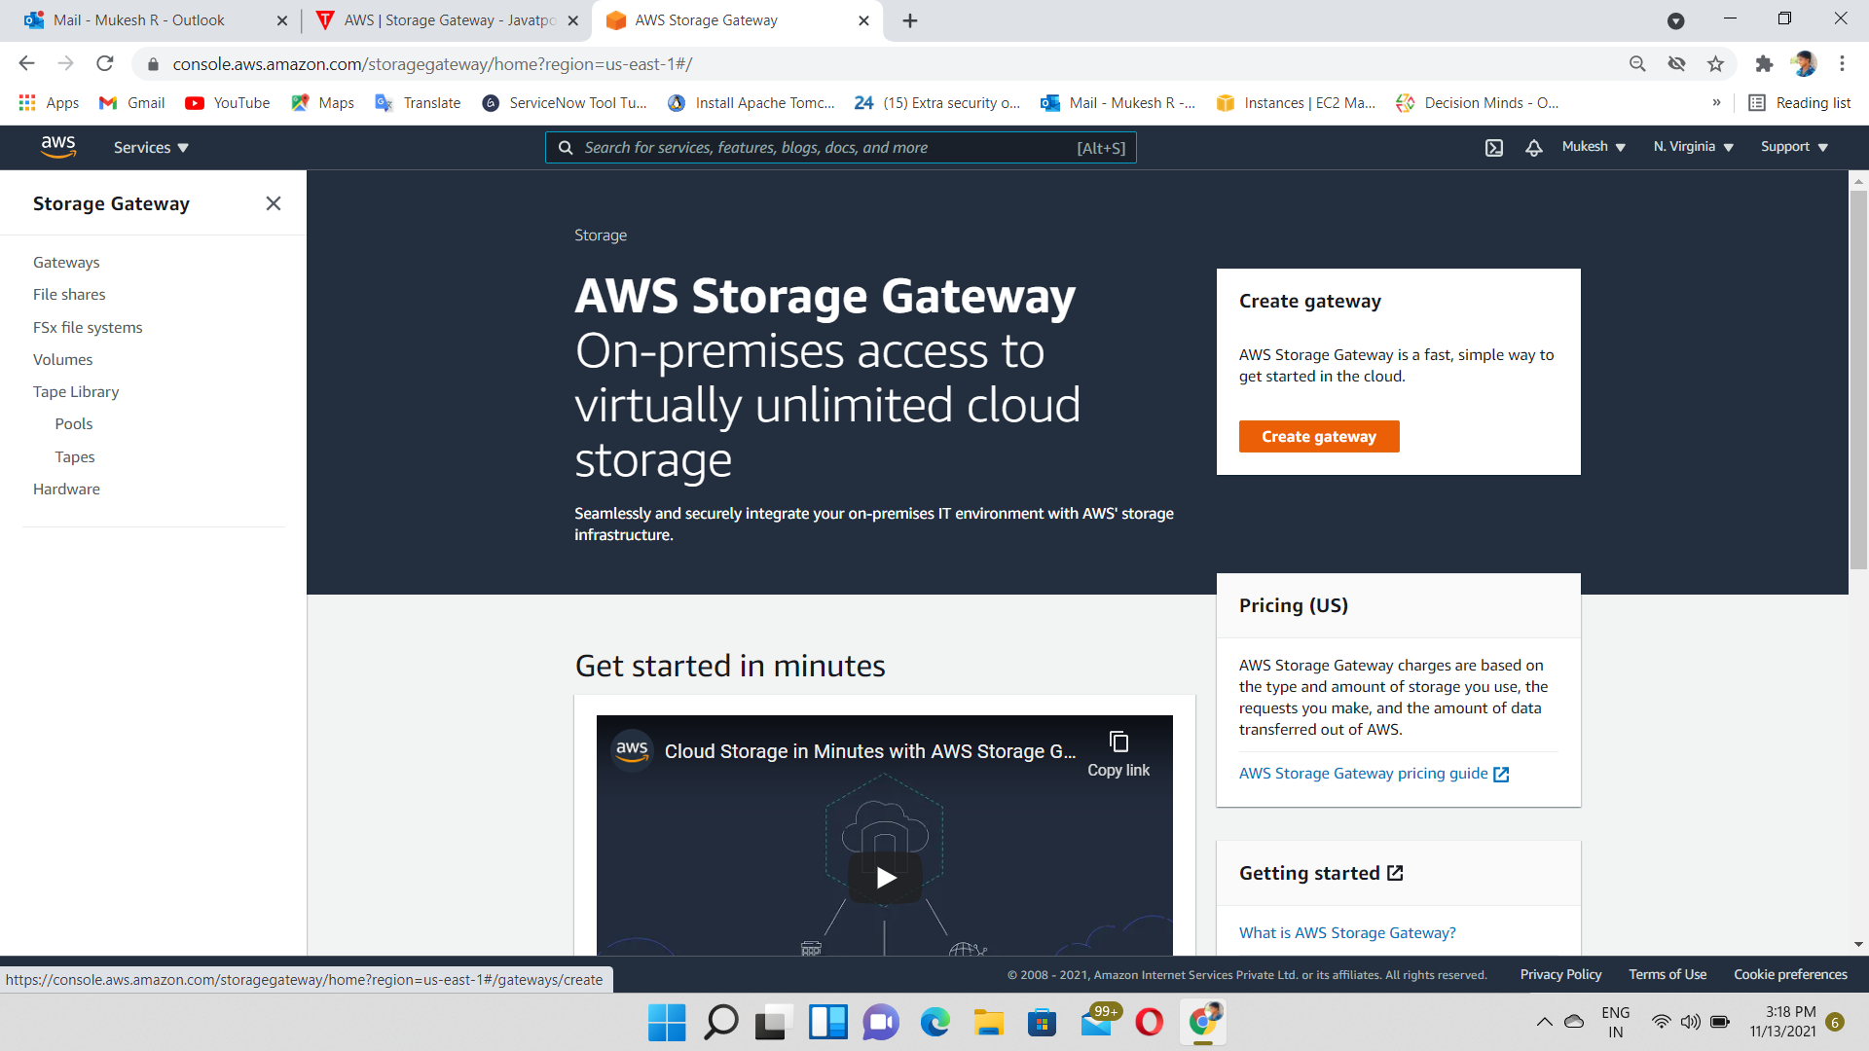

**Select Gateway type🡪Volume Gateway**

Volume Gateway is an interface that presents your applications with disk volumes using the ISCSI block protocol. The iSCSI block protocol is block-based storage that can store an operating system, applications and also can run the SQL Server, database.

Data written to the hard disk can be asynchronously backed up as point-in-time snapshots in your hard disks and stored in the cloud as EBS snapshots where EBS (Elastic Block Store) is a virtual hard disk which is attached to the EC2 instance.

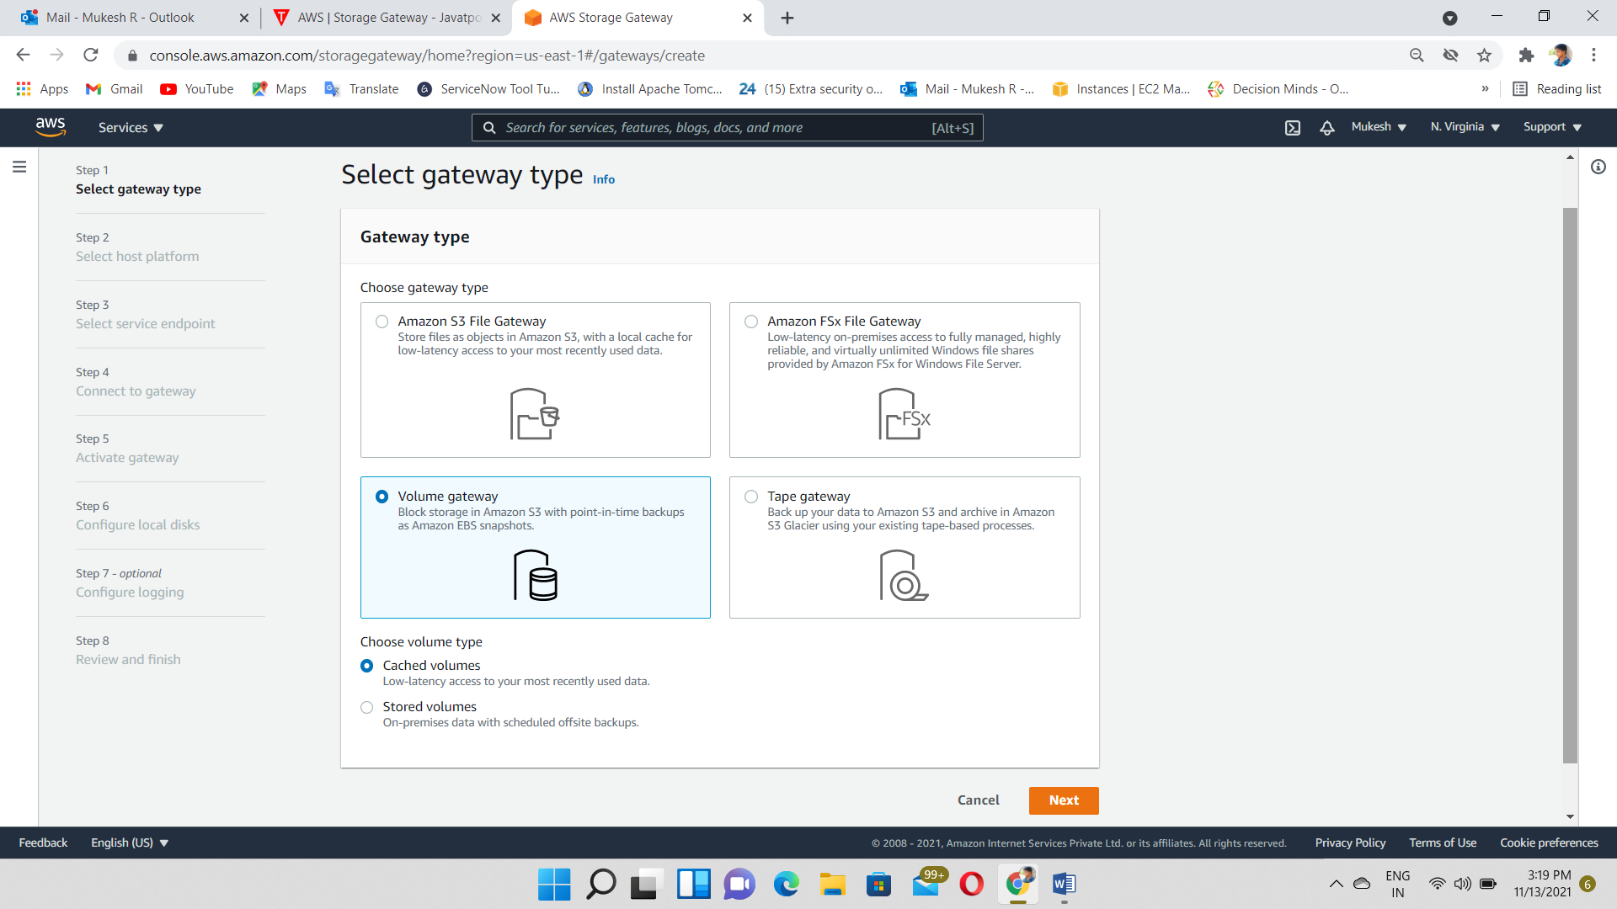

Select Amazon EC2 and Setup instructions for EC2

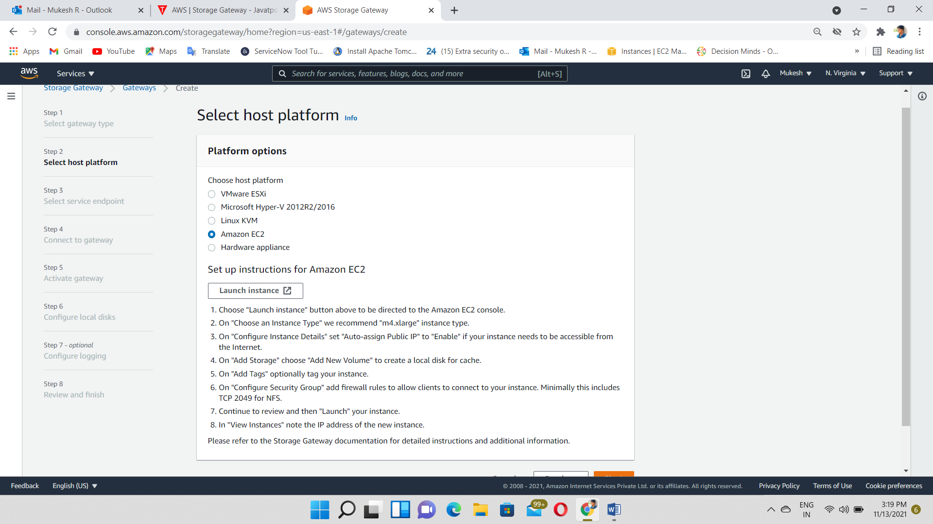

Select m4.xlarge instance type

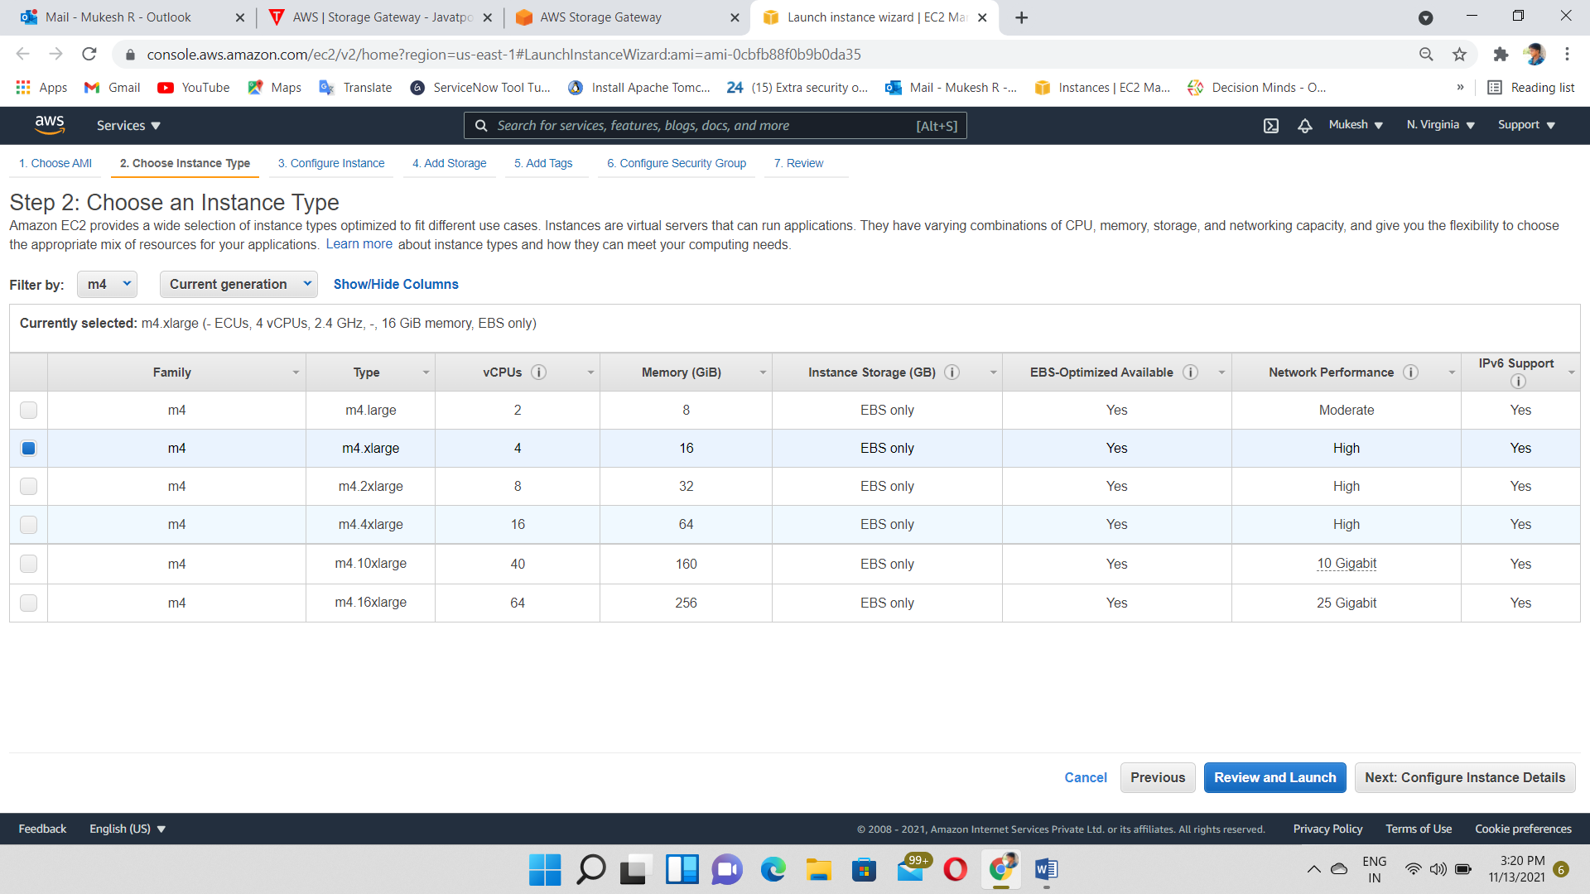

Add 2 more volumes with 50GiB

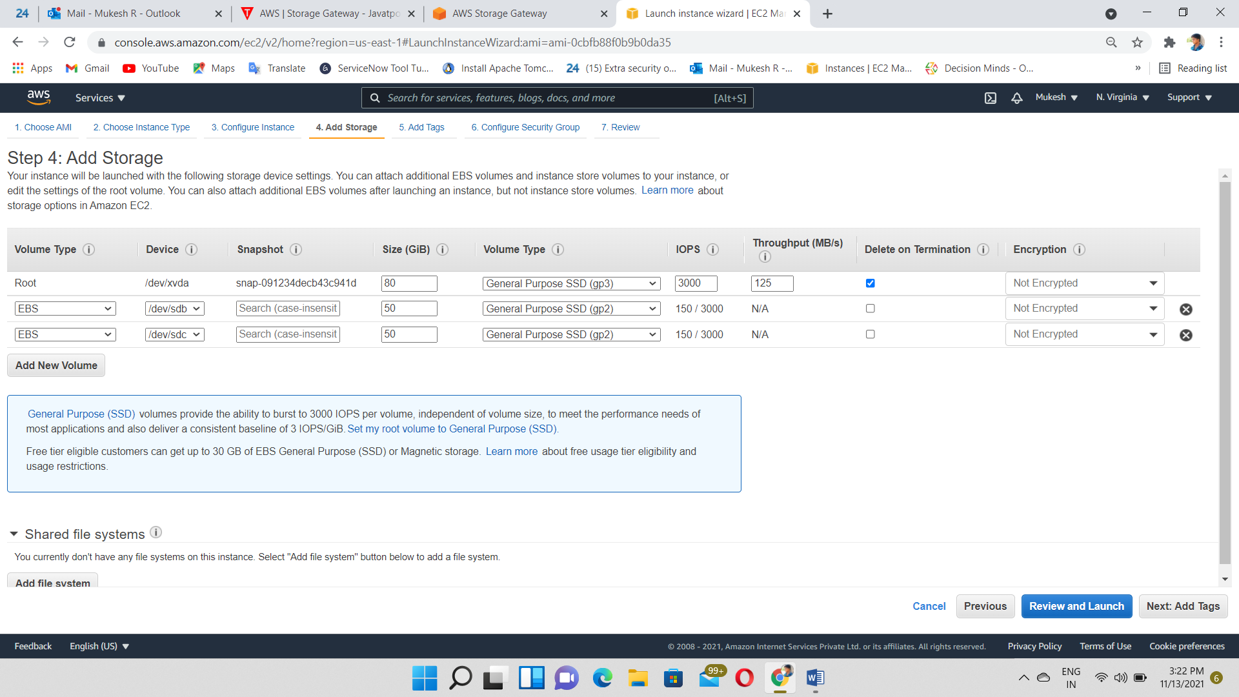

Server instance Created

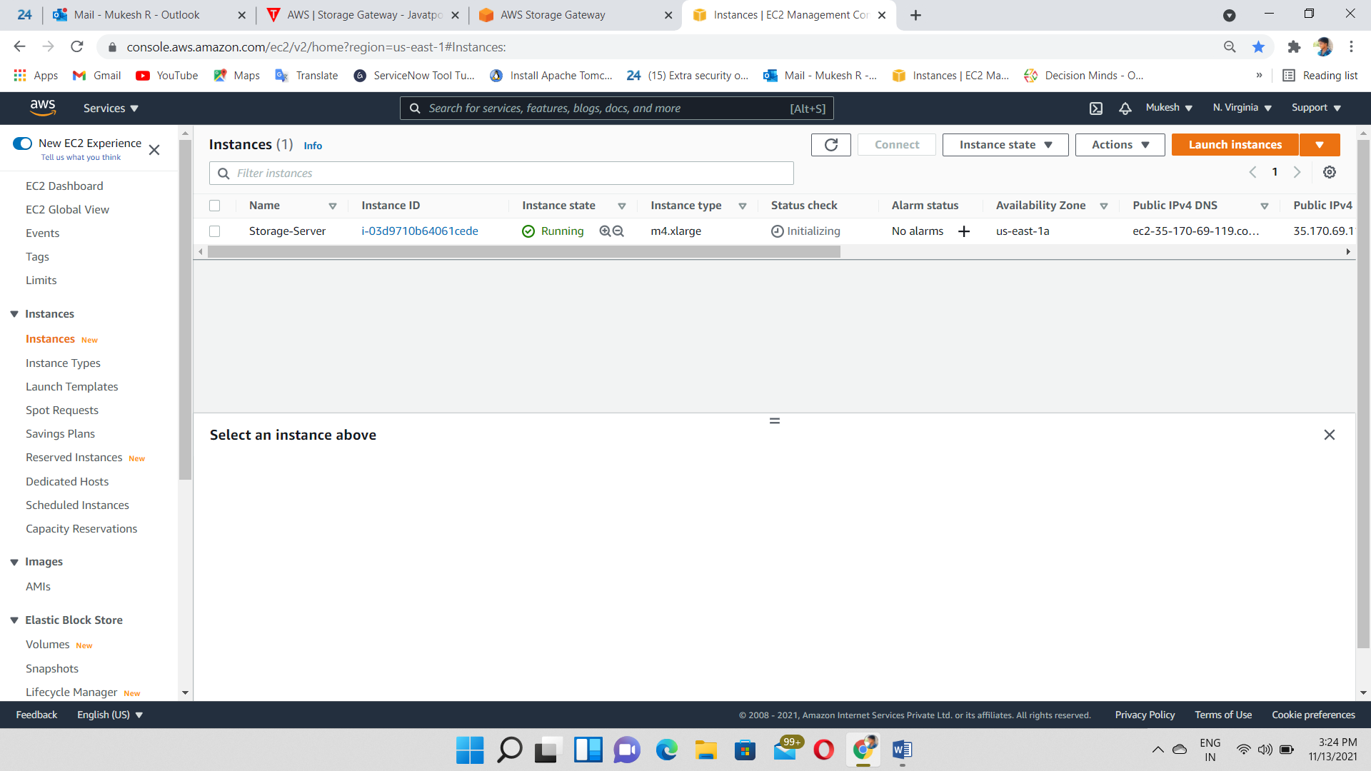

Choose🡪 Public Endpoint

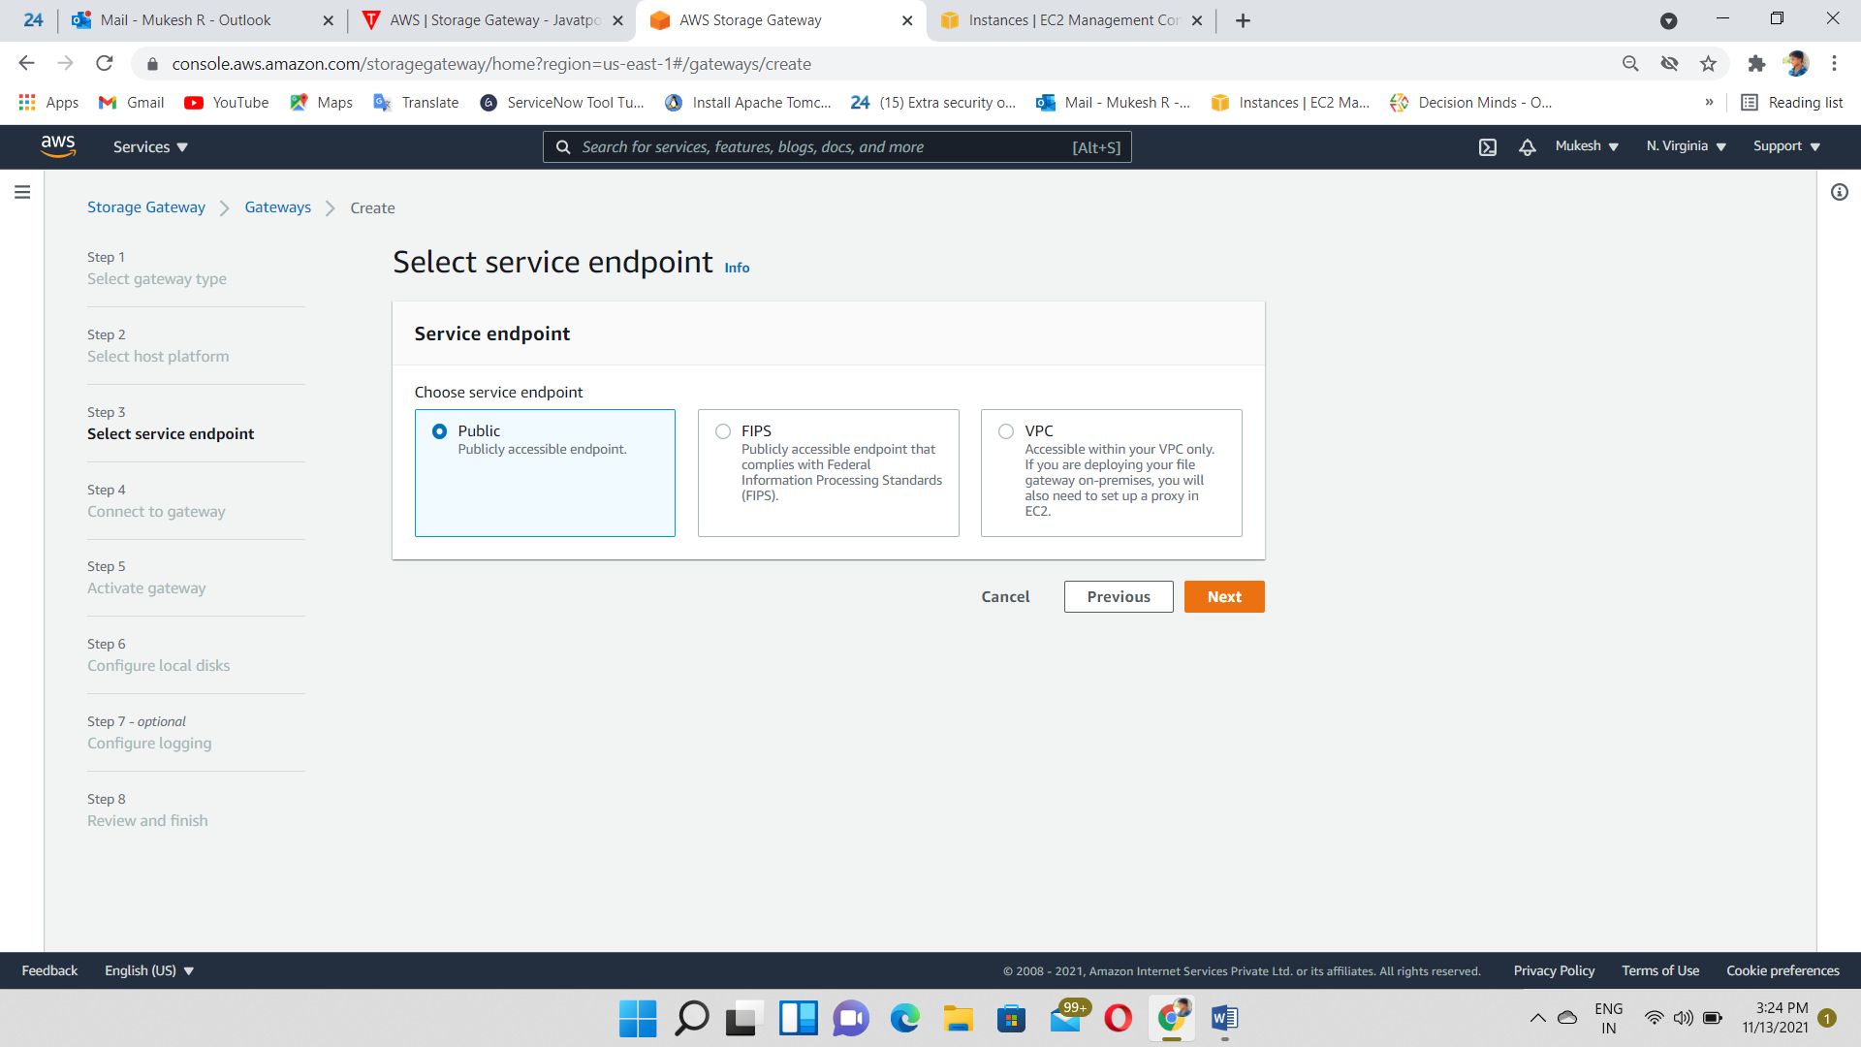

Copy & Paste the Public IP of (storage Gateway)server Instance

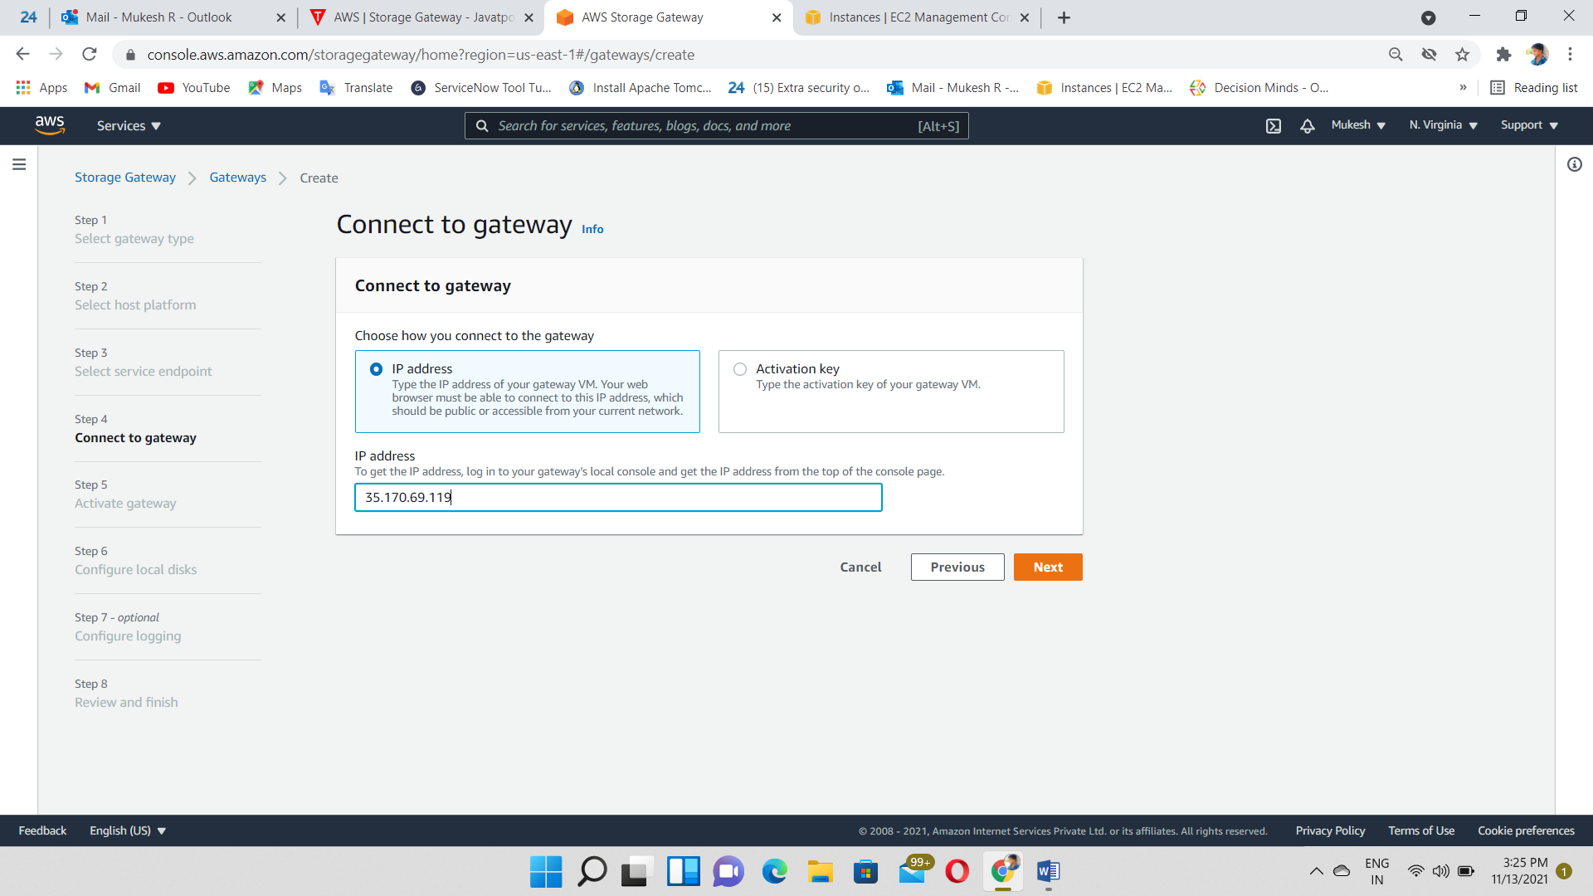

Give Gateway Name and activate the Gateway

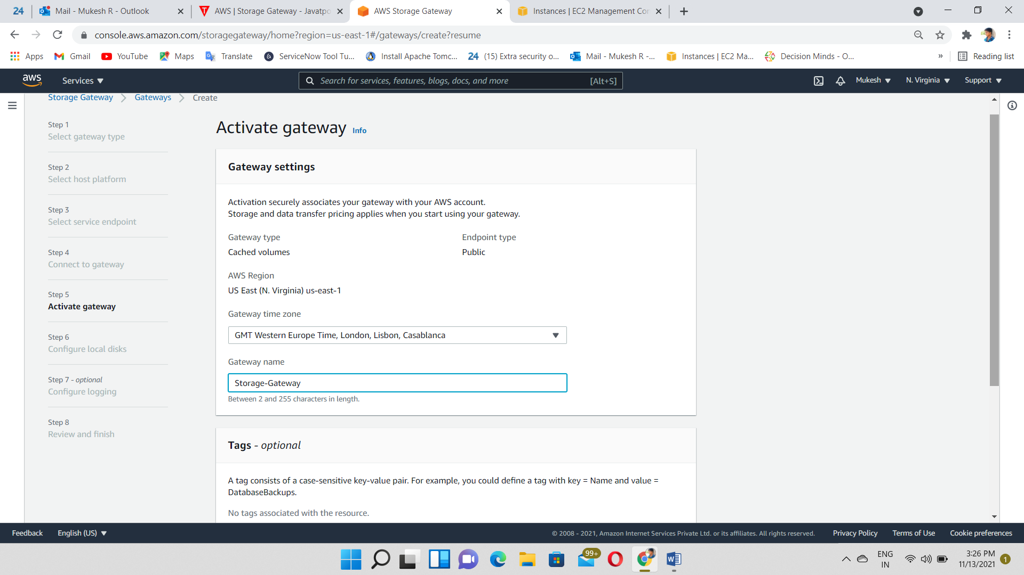

Configure Local disk

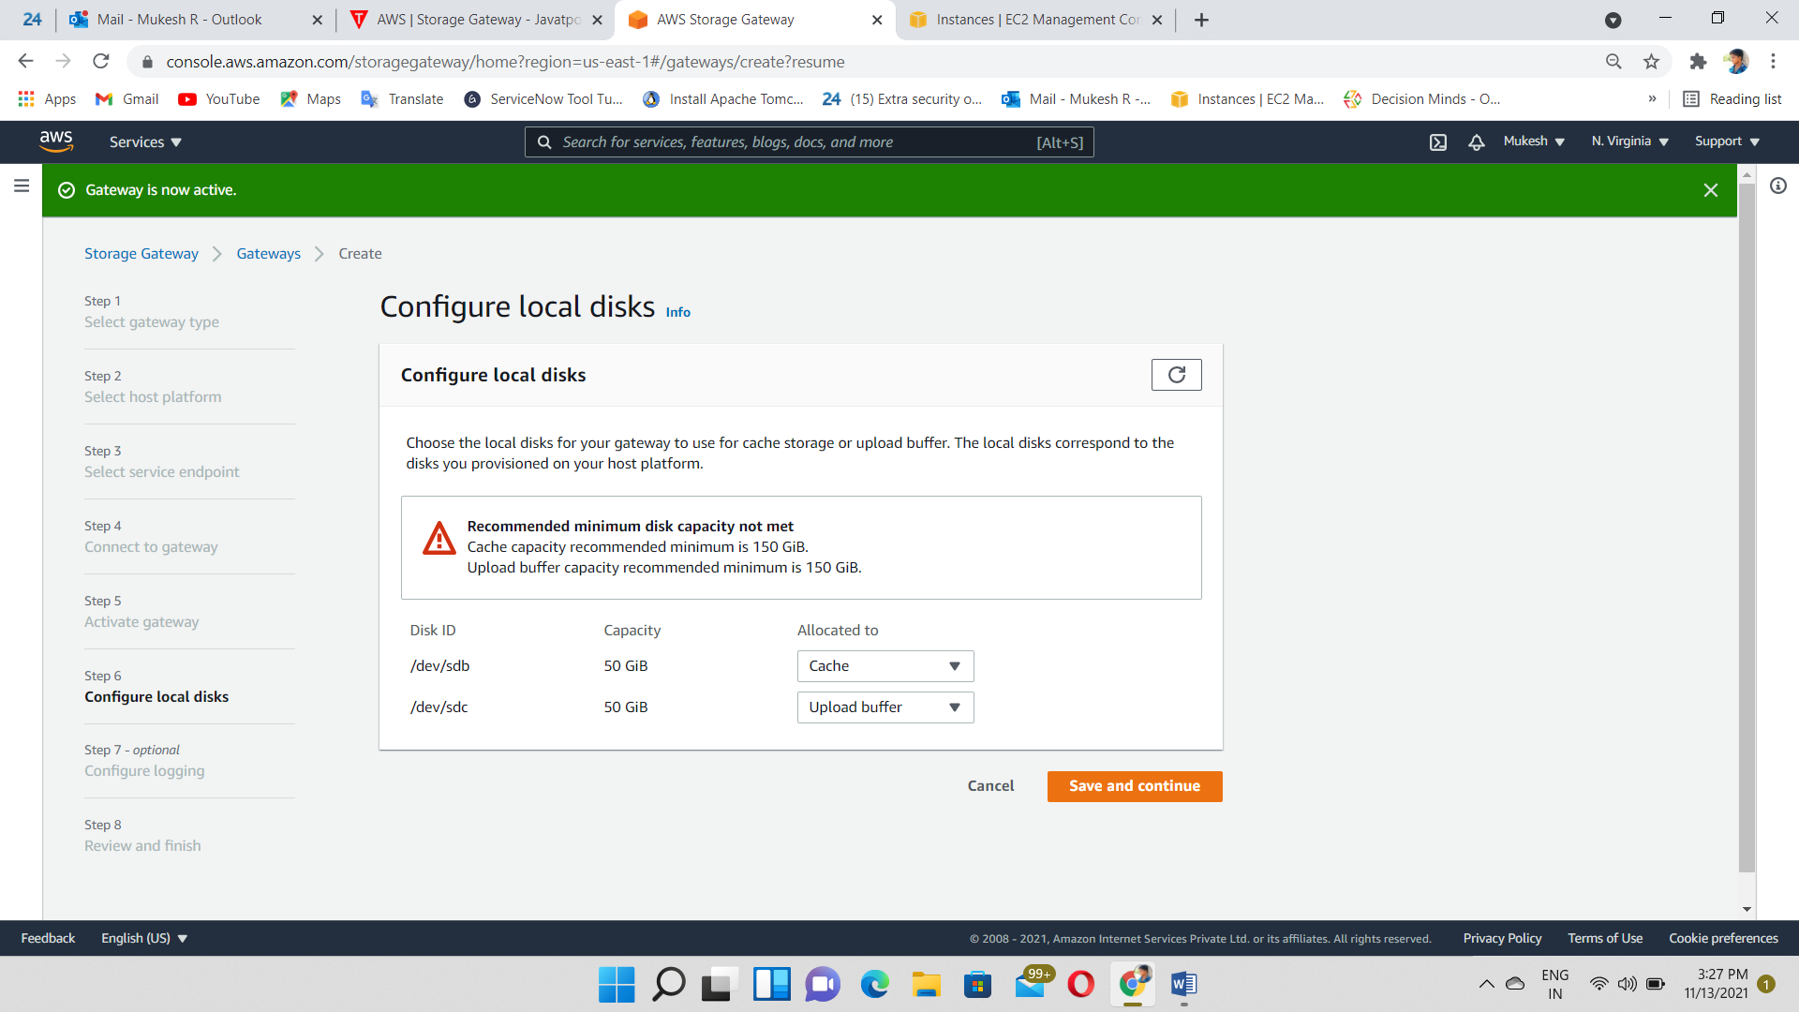

Select the Disable Logging

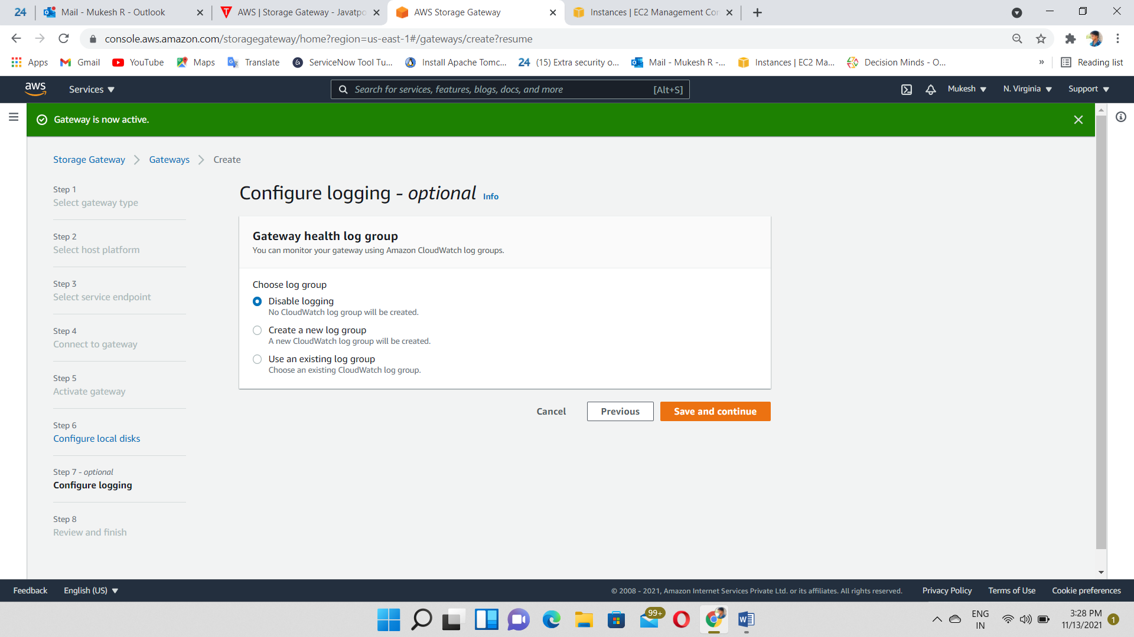

Storage Gateway Created and Status also running

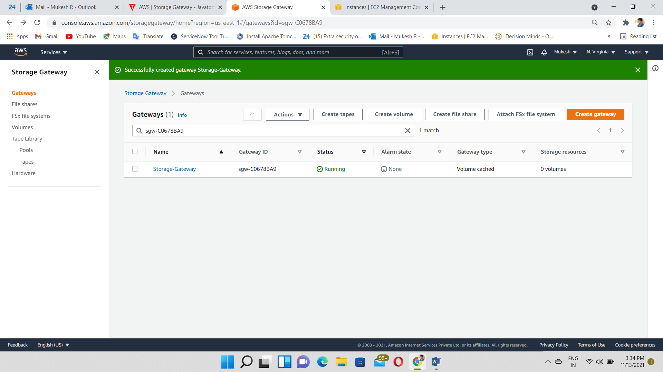

Create a Volume and give the ISCSI target name

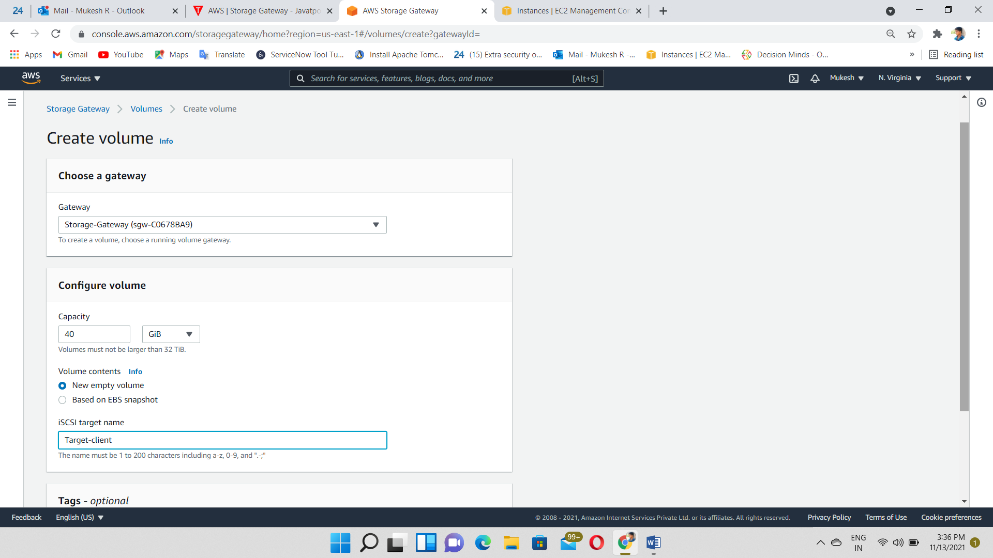

Cancel the configure authentication

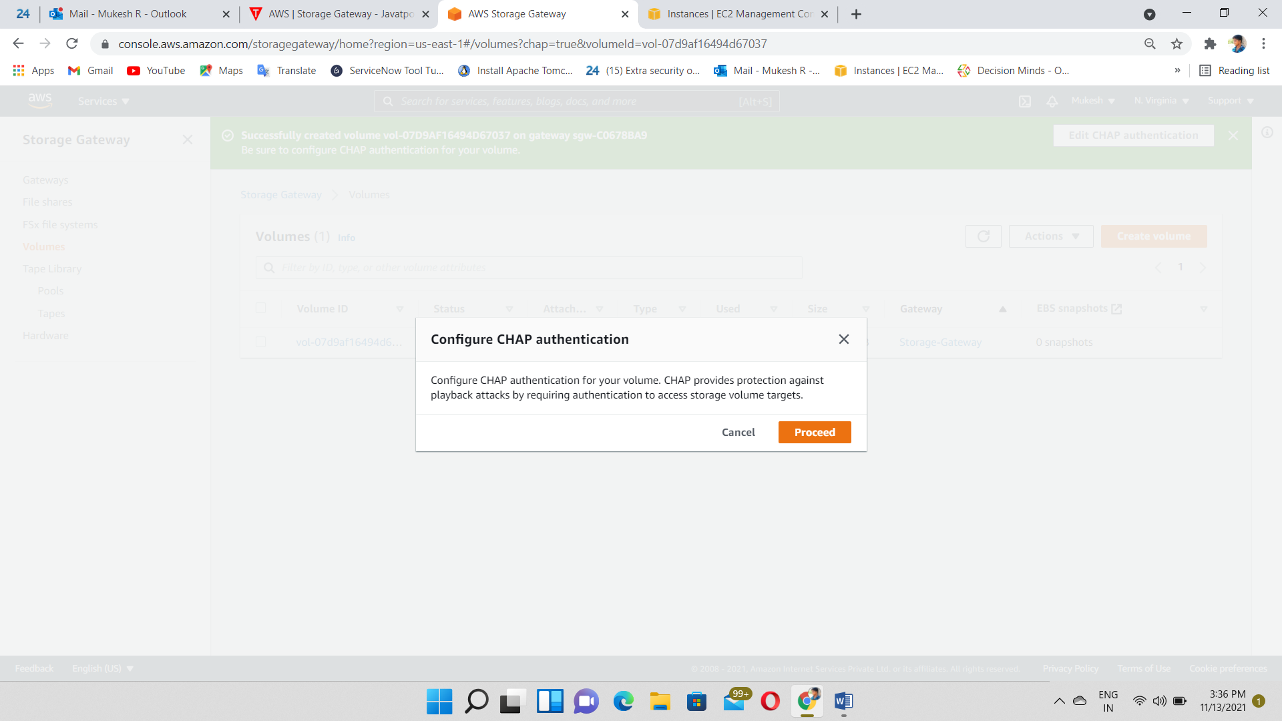

Volume Created and Attached volume to the Storage Gateway

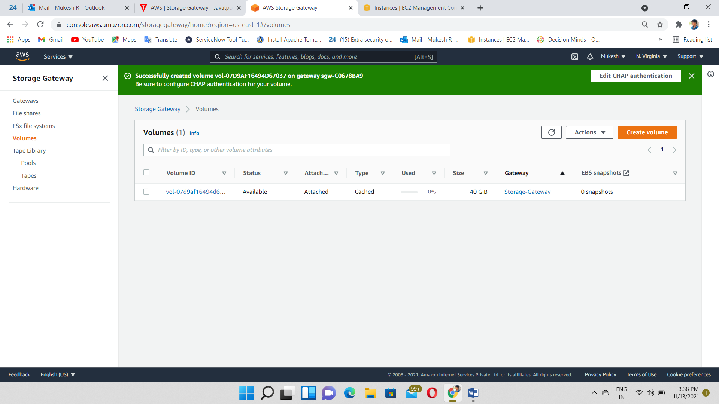

Create a windows instance (Client-1)

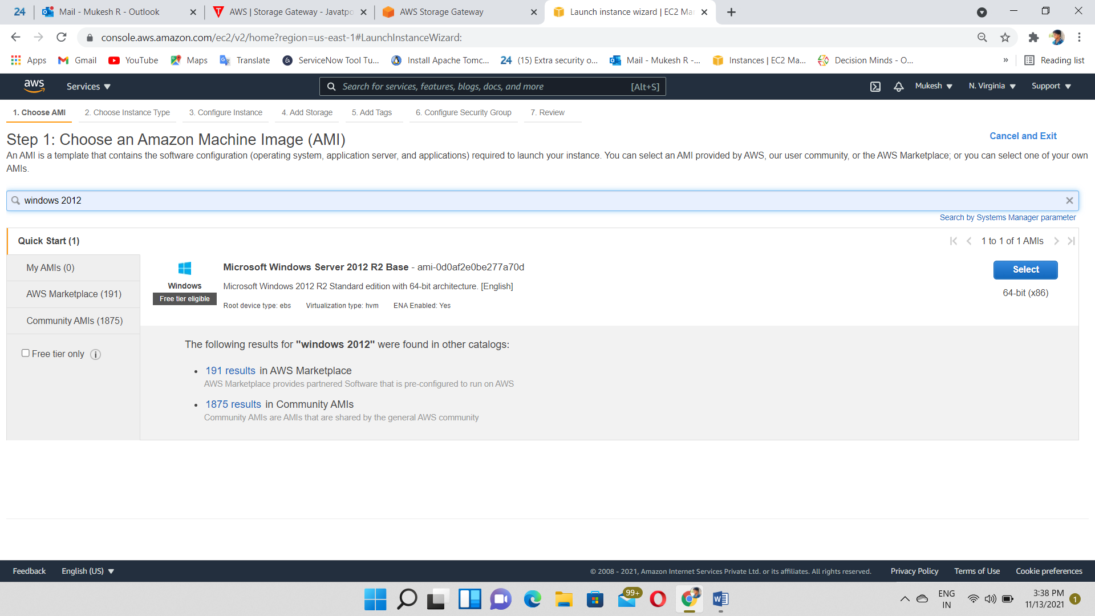

Login to the Client-1 machine using RDP

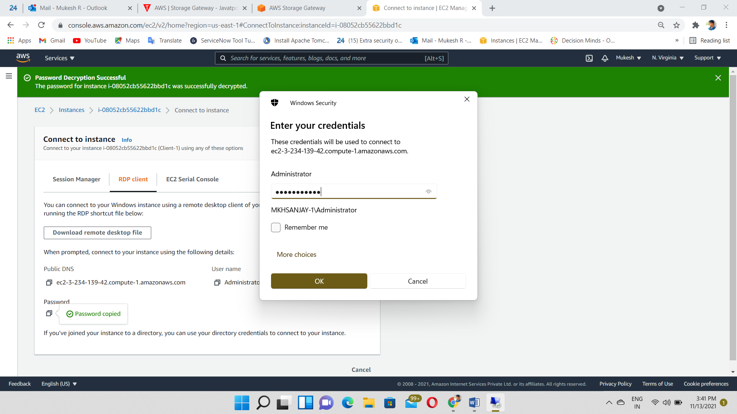

Search “ISCSI initializer”

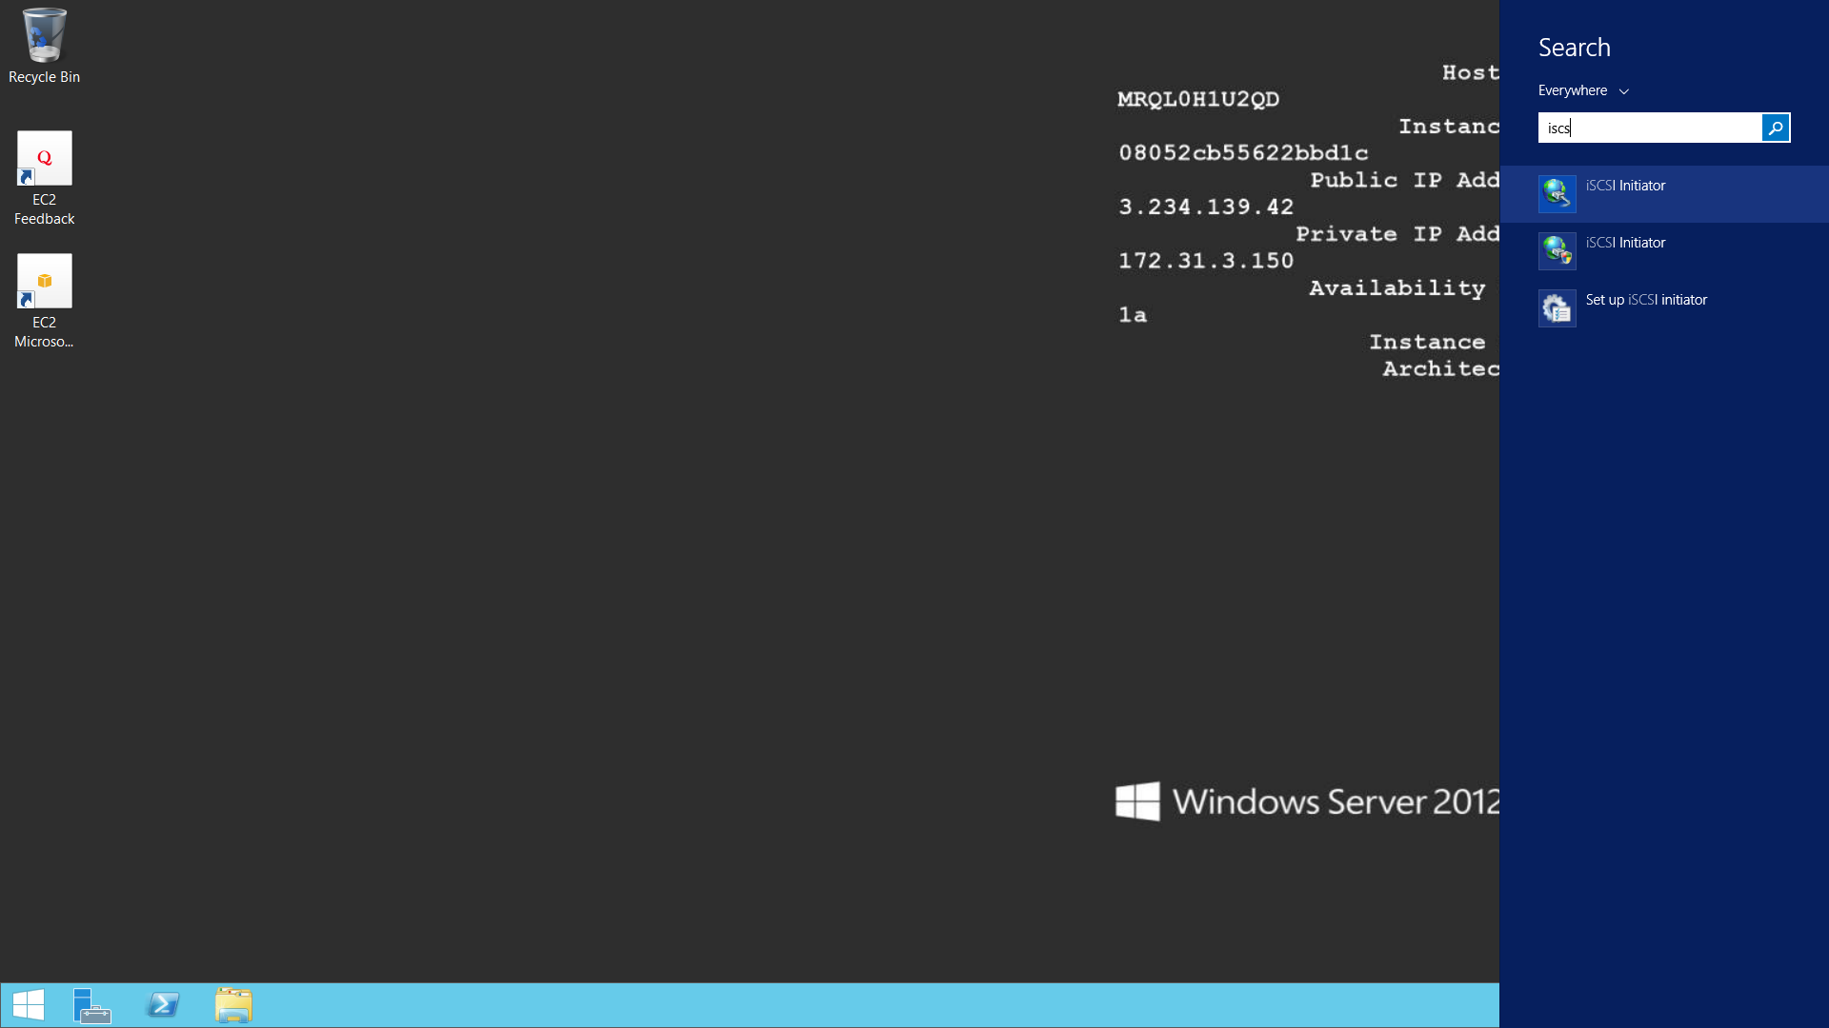

Select the ISCSI Initializer

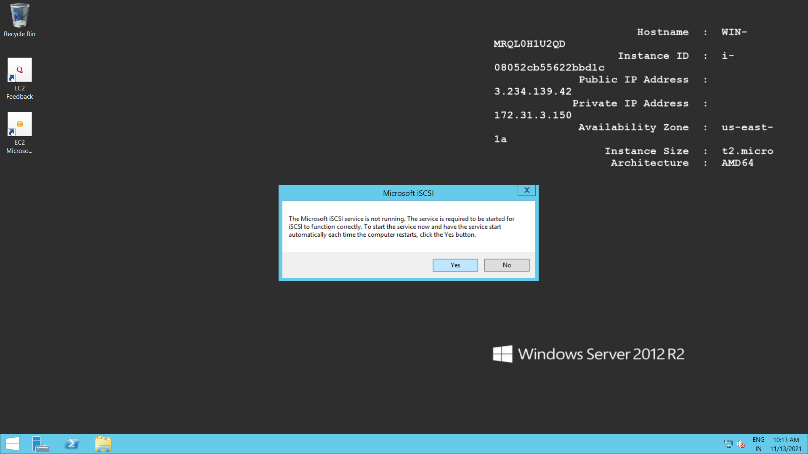

Copy & Paste the Private IP of Server Instance and Select Quick Connect

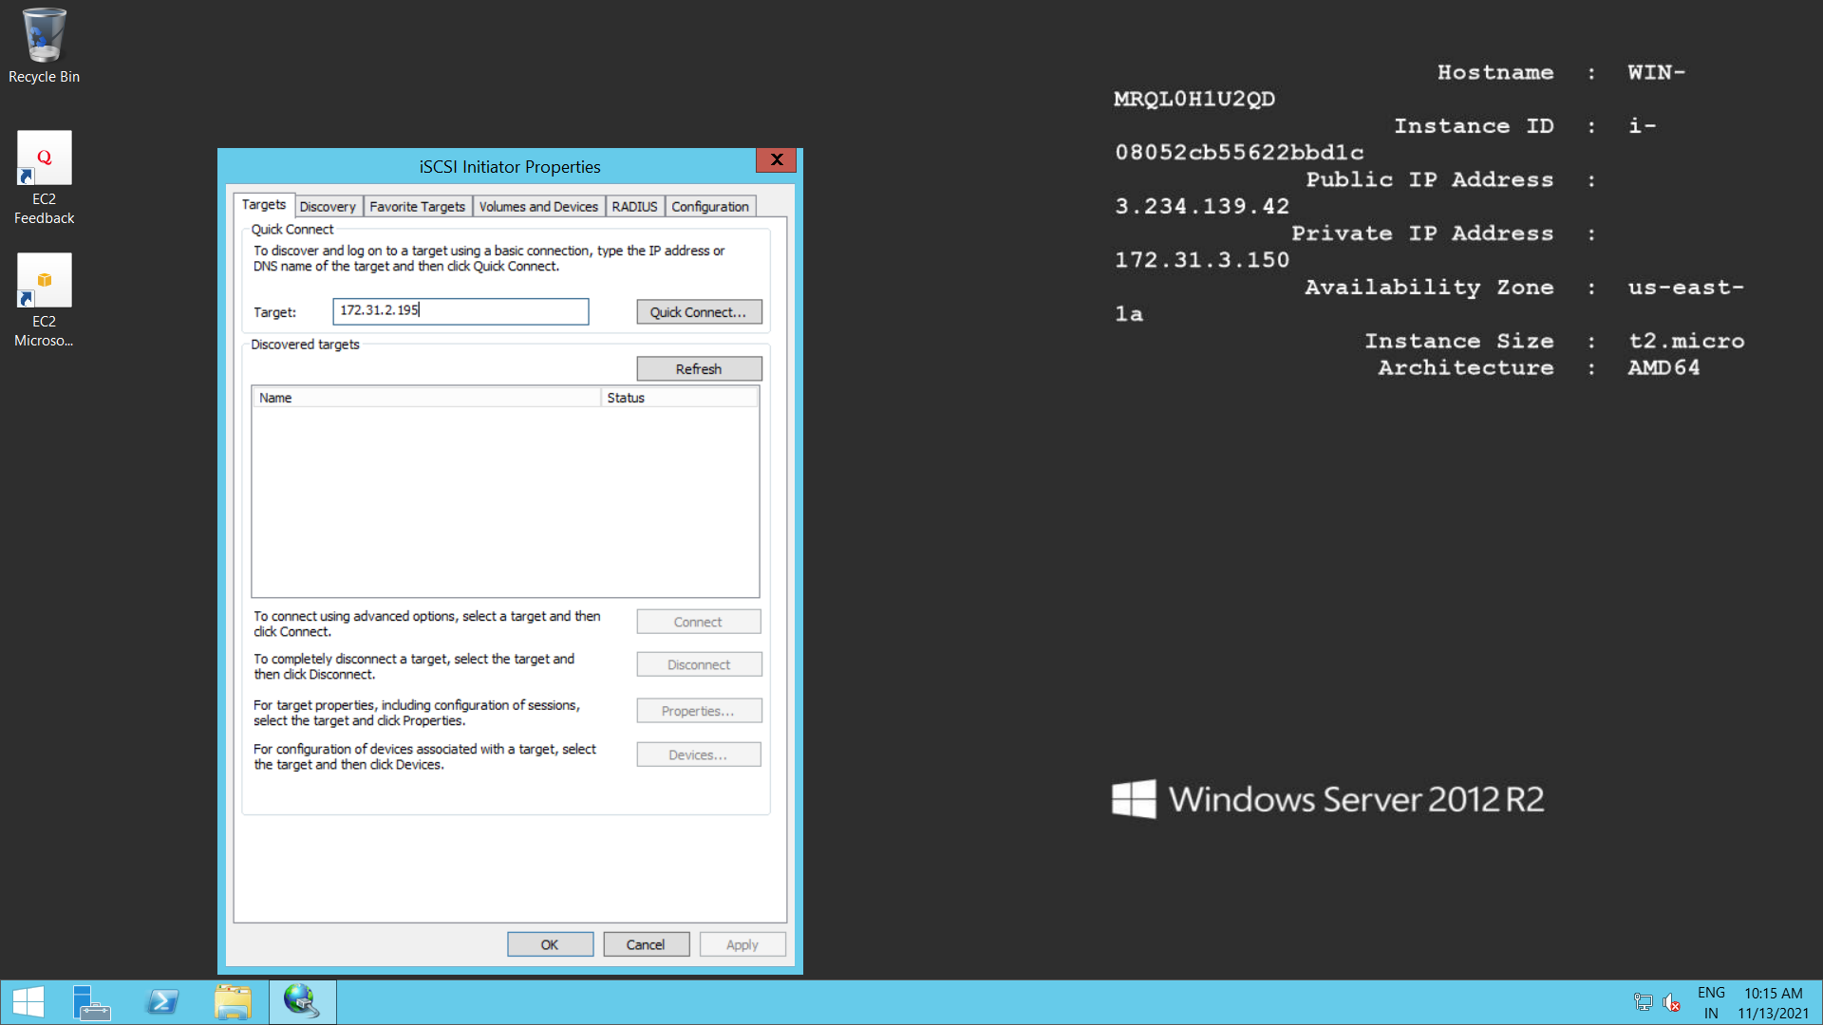

New Volume Created and Make it online

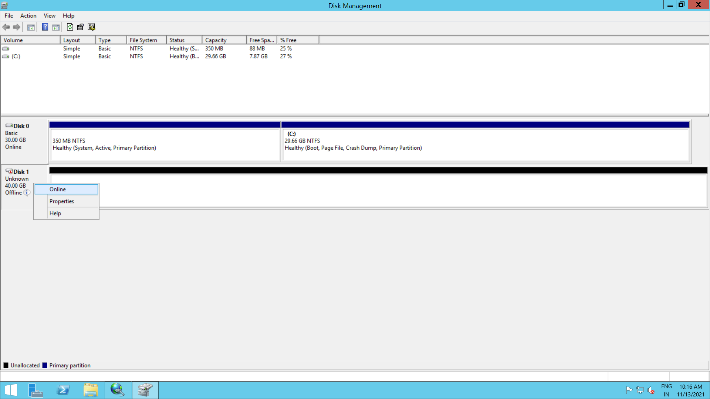

Initialize the Disk

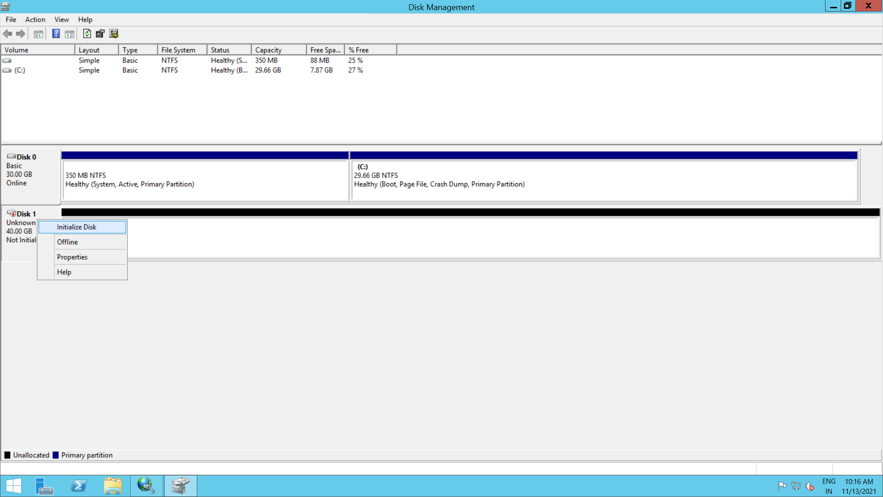

Create a disk

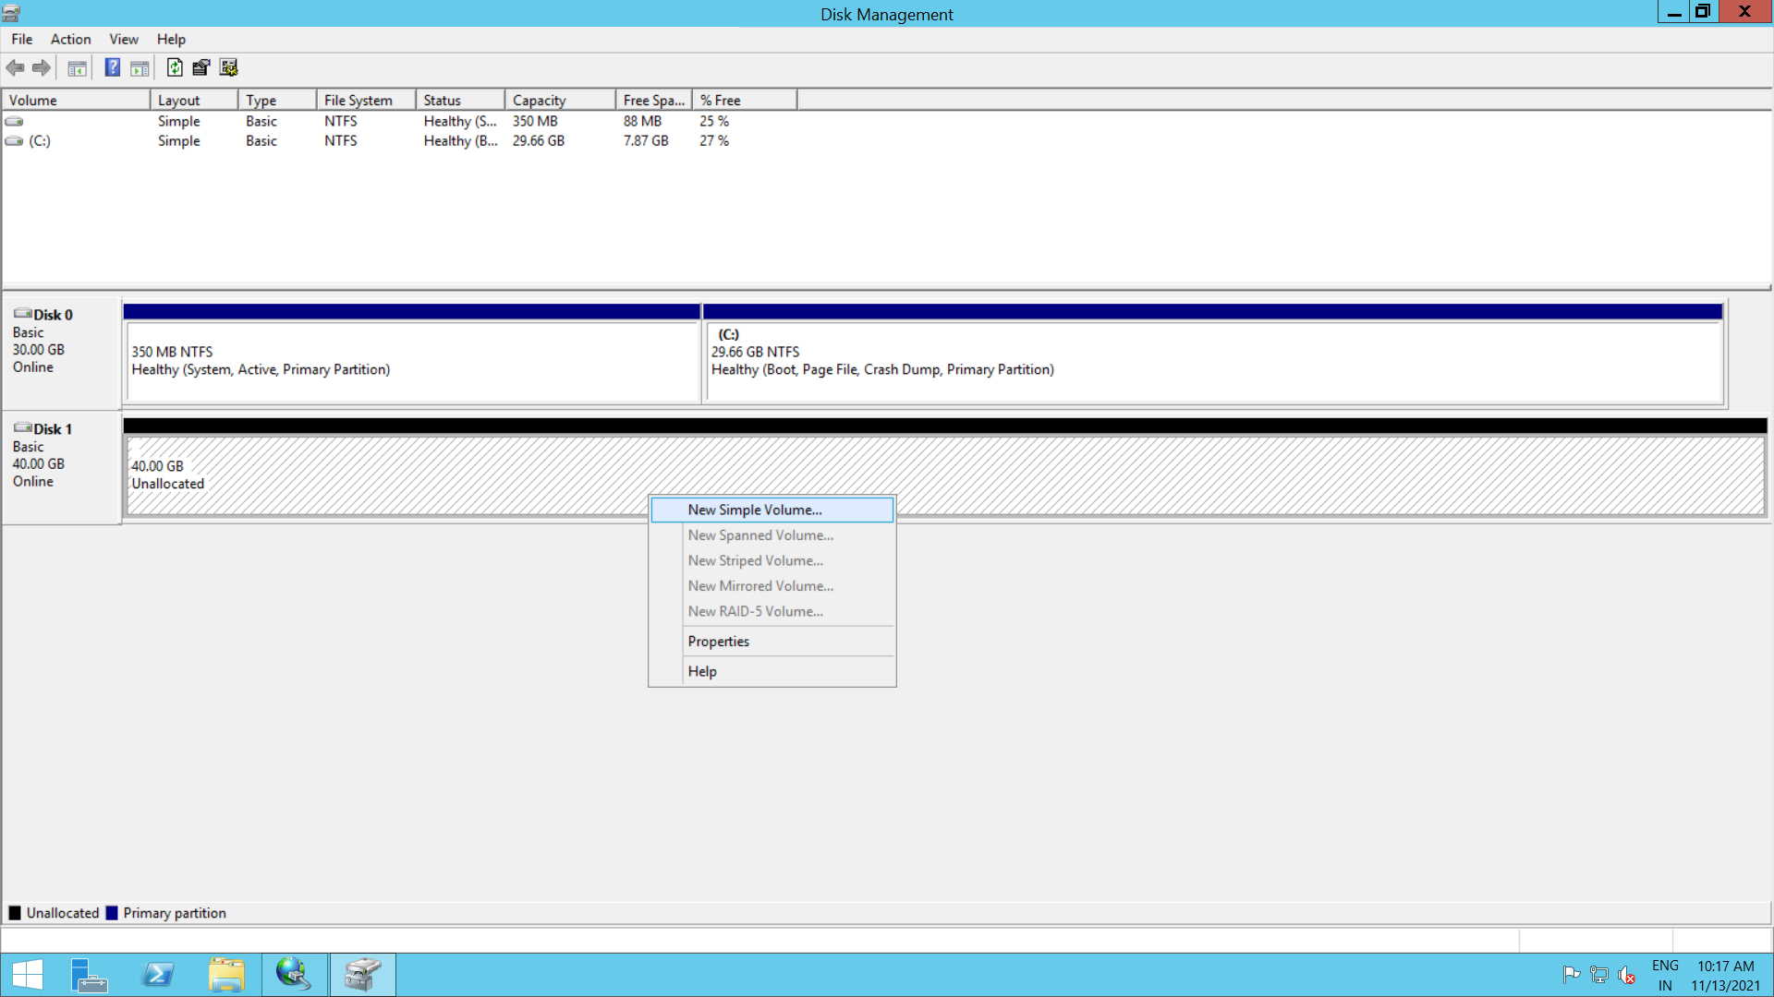

Select the Disk Size

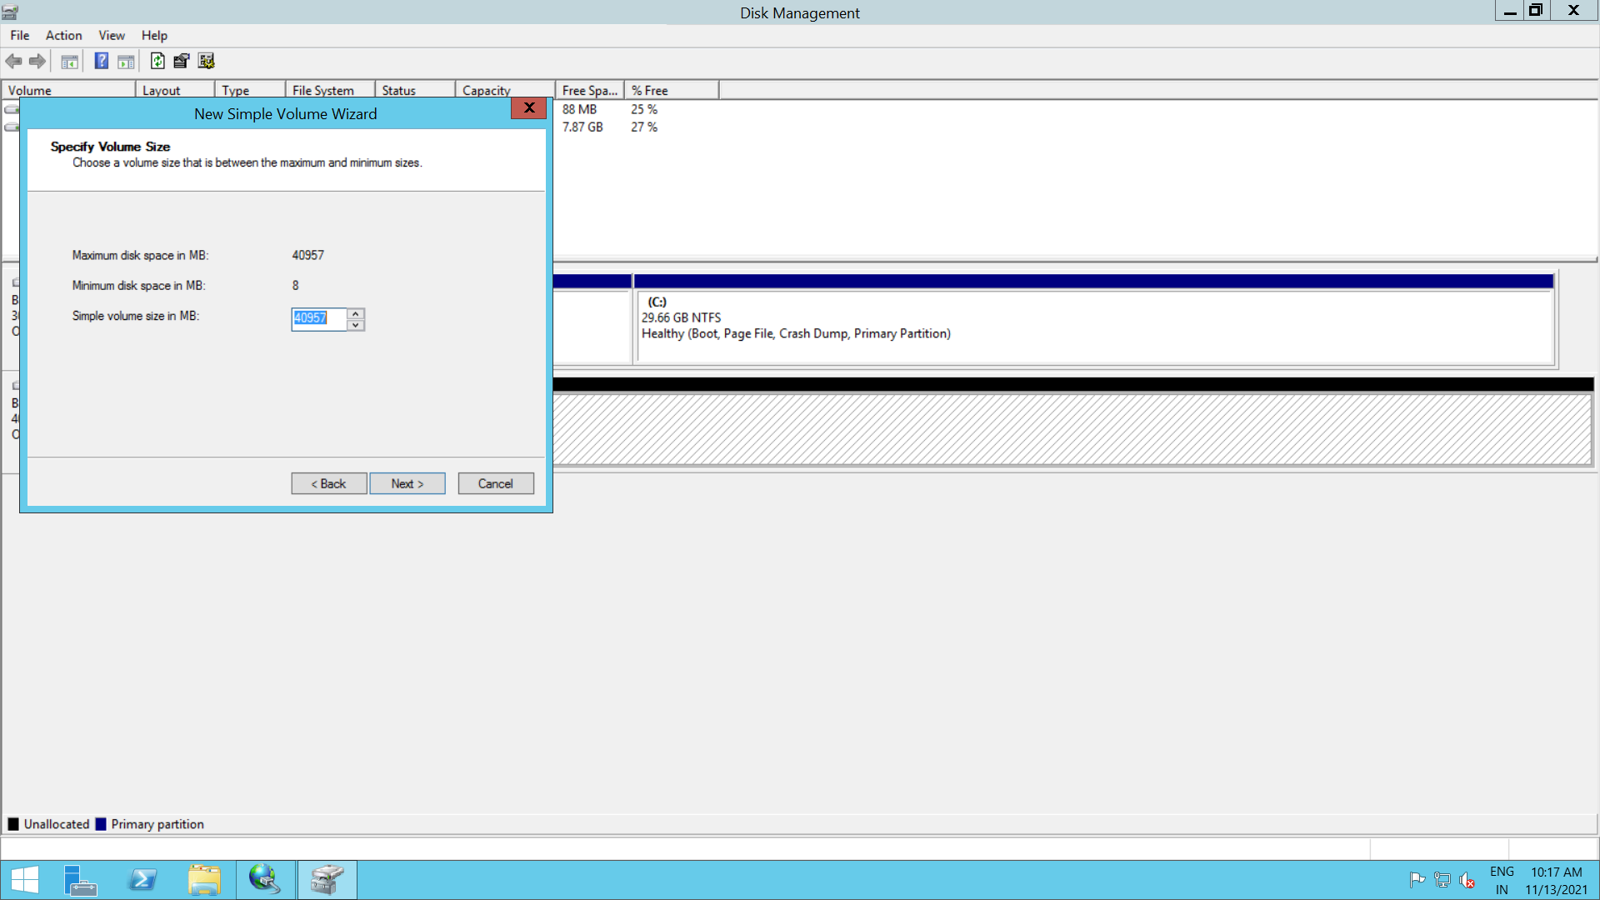

New Disk created

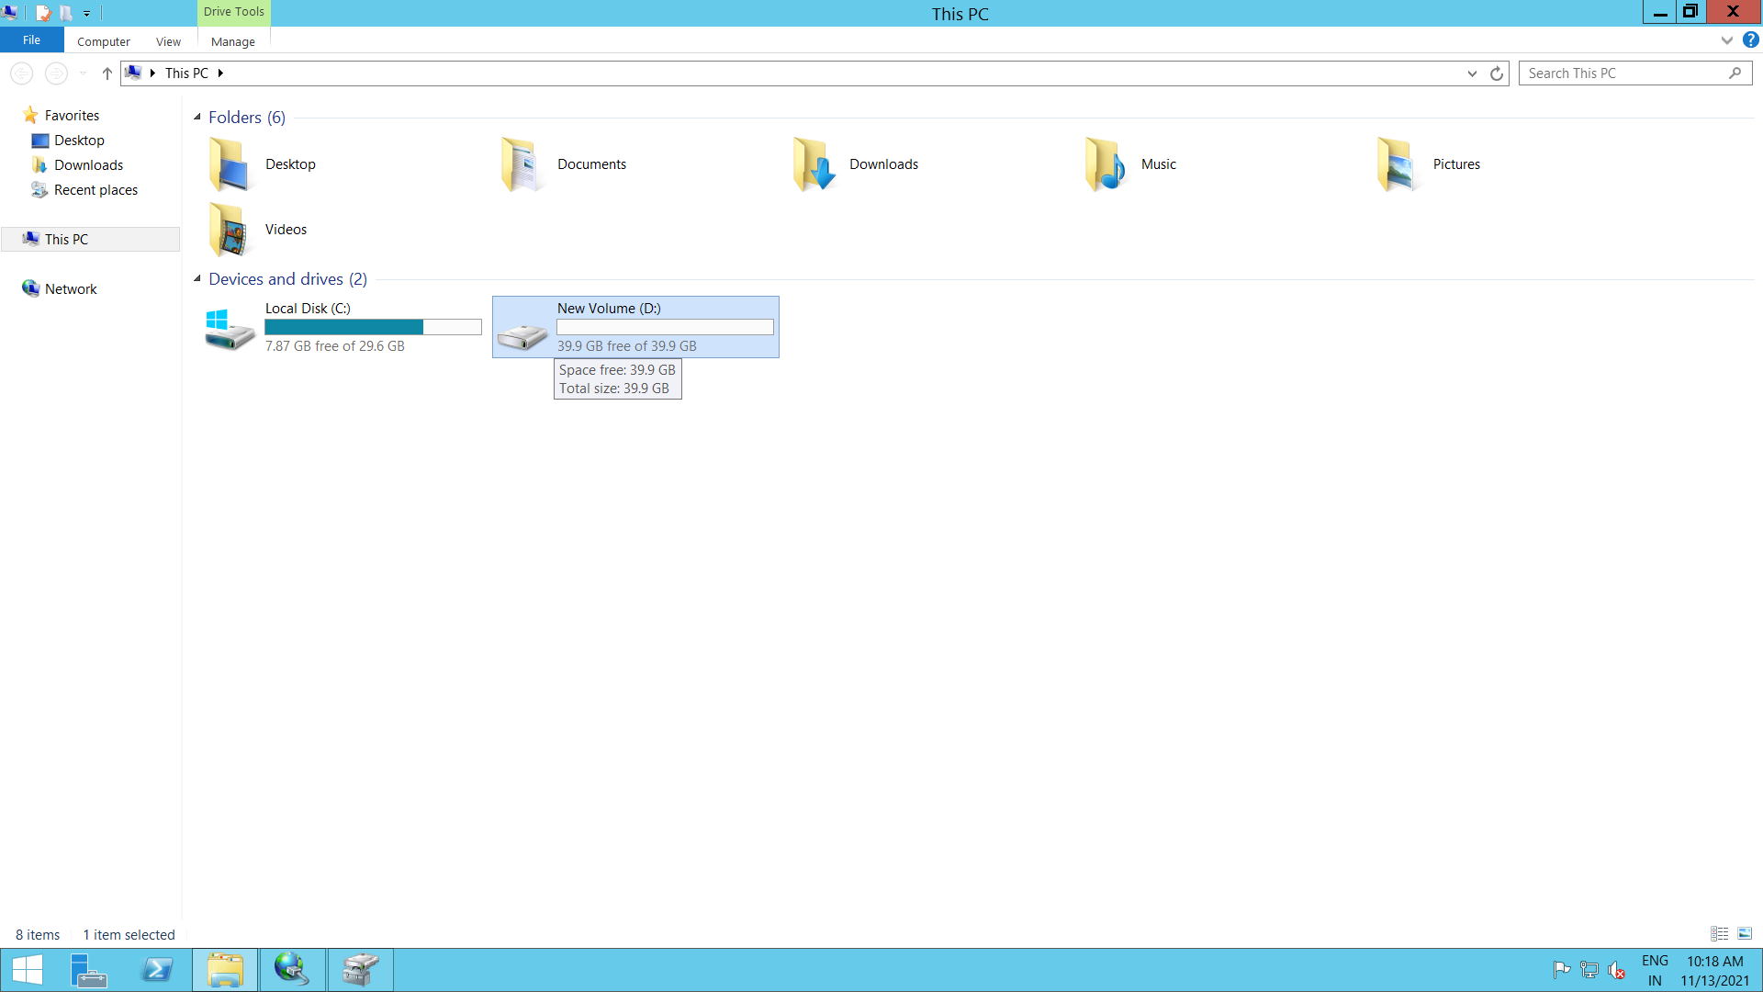

Create a Text file inside the new disk

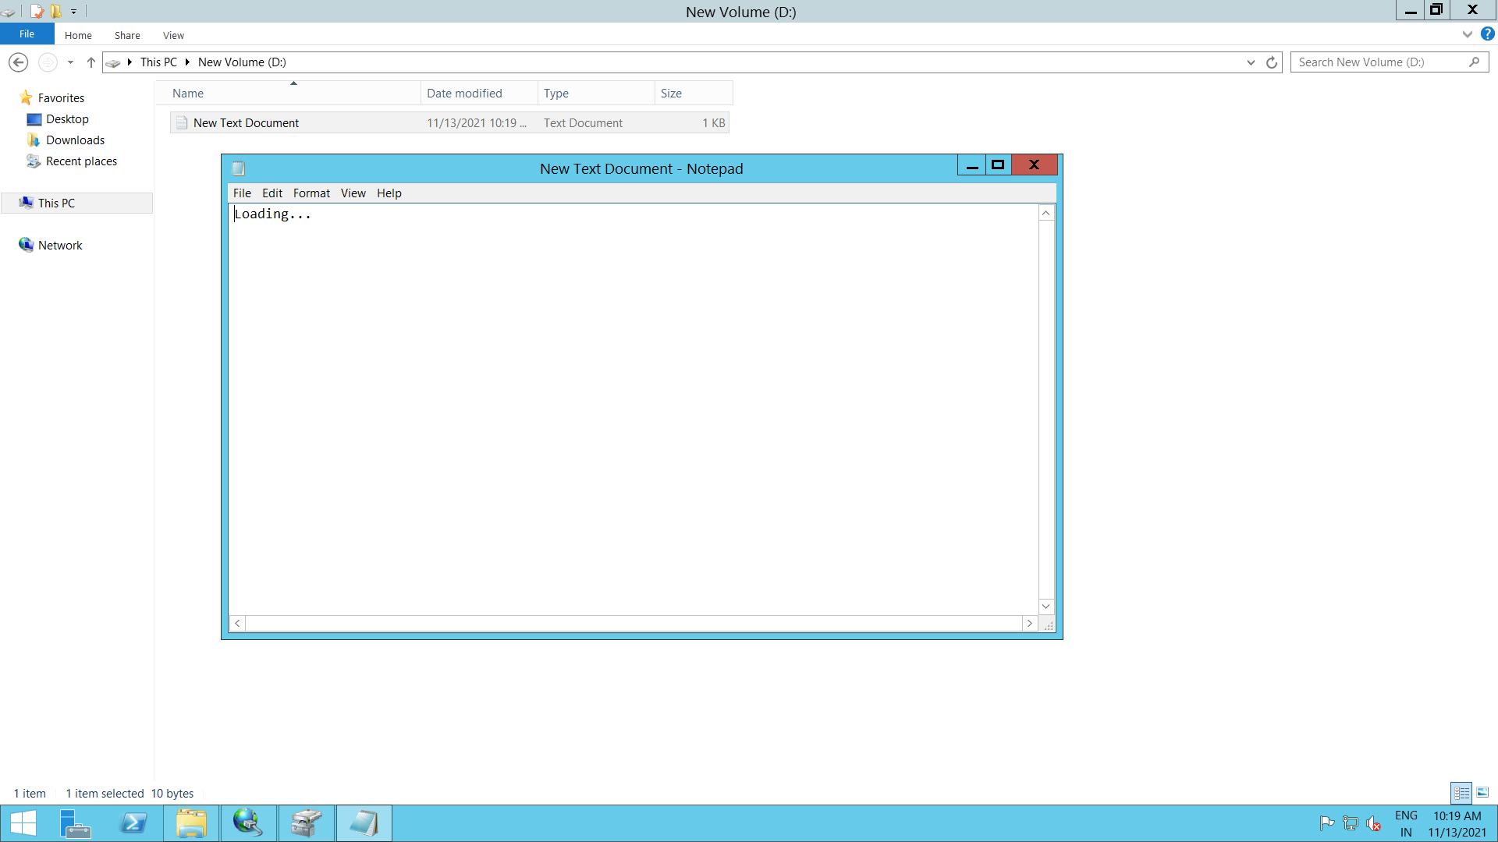

Create a another windows instance (Client-2)

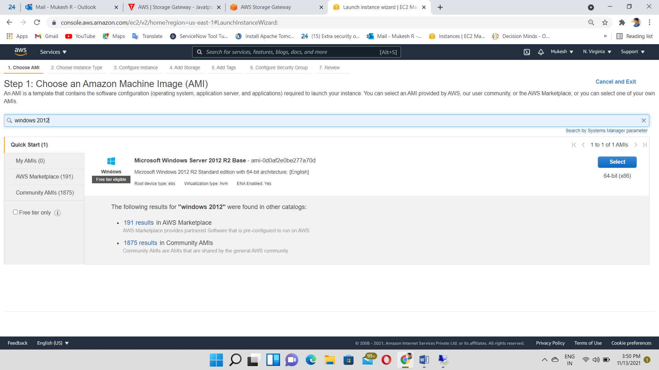

Login to the Instance (Client-2) using RDP

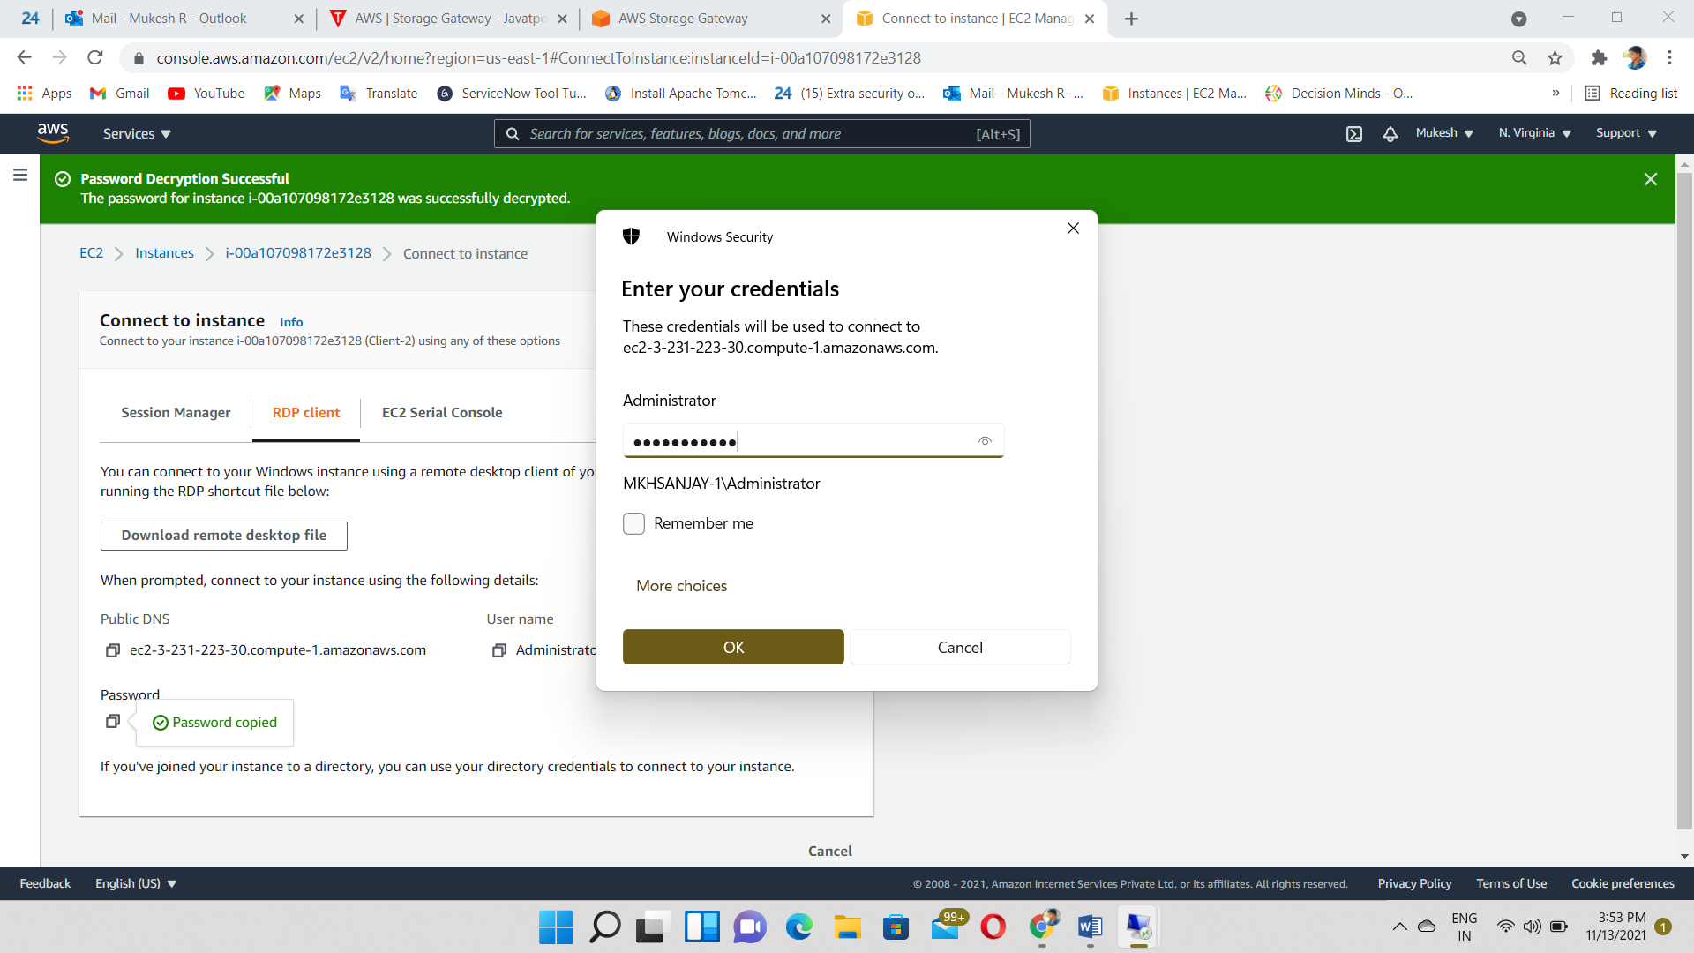

Search “ISCSI Initiator”

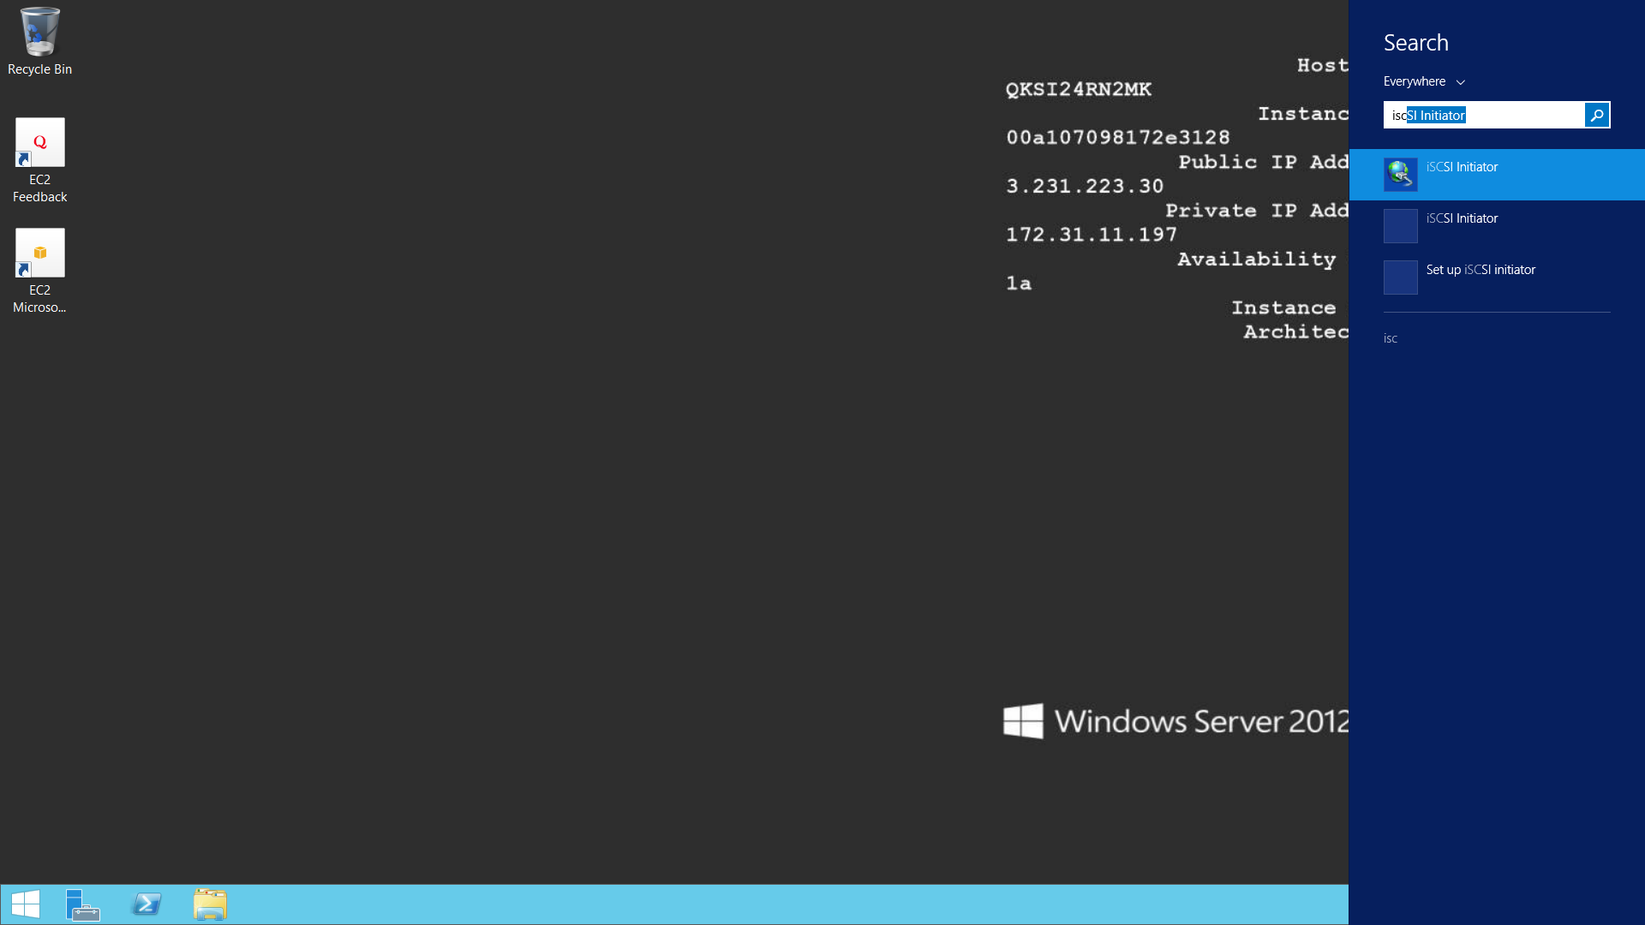

Copy & Paste the Private IP of Server Instance (Gateway Instance)

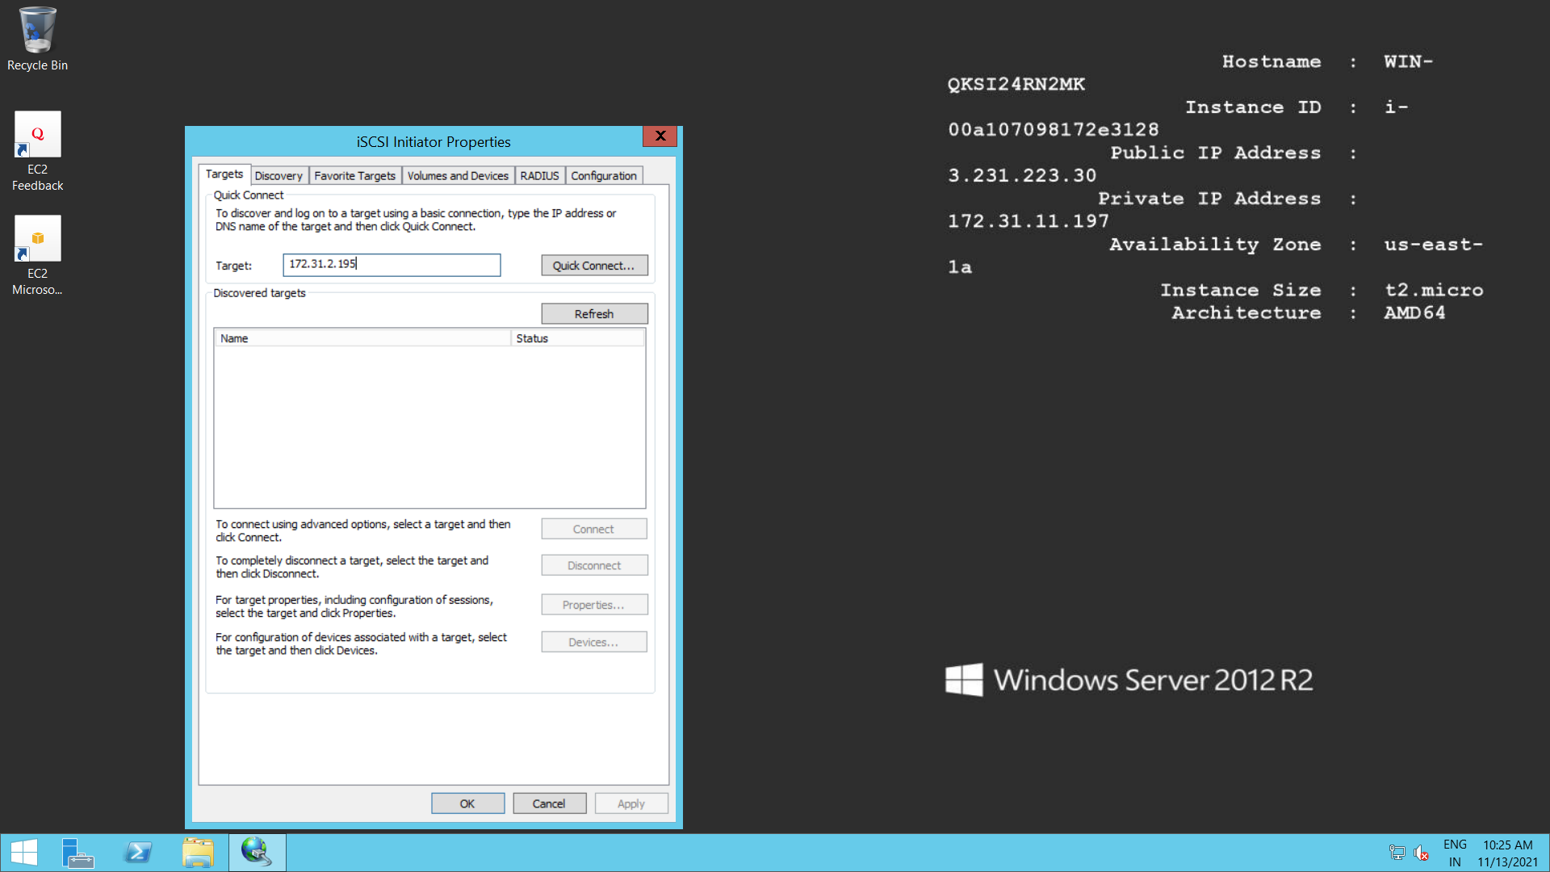

New Volume Created

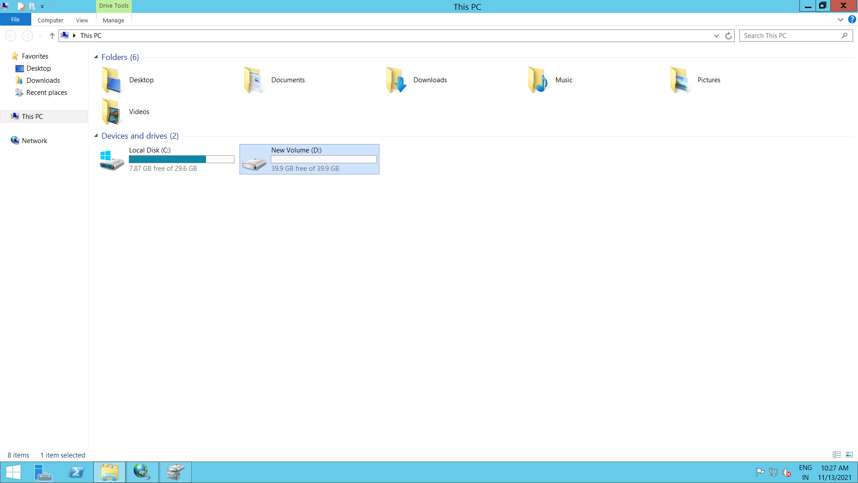

Output: File also replicated

